**Network Fundamentals Lecture ６ Notes**

**Communications Media**

* Communications media for LANs may be either by means of wiring or by wireless approaches
* Wiring approaches consist of:
* -Twisted-pair cabling
* -Coaxial cable media
* -Fibre-optic cabling
* Wireless approaches consist of:
* -Radio or infrared transmission
* -Satellites as a special case of radio broadcast

**The Wired Approach**

* 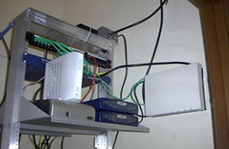Modern wiring plans normally follow standard structured cabling methods
* -Wired closets on each floor of a building
* -An orderly cabling installation
* Utilizing cabling racks
* -Patch panel
* -Wiring distribution
* -Network access devices

**Cabling Media Choices**

* The network developer has a number of alternative cabling media choices
* -Twisted pair, coaxial cable and fibre optic cabling
* The cabling selection issues include;
* -The required data rate (including growth considerations)
* -The level of electrical interference (Would your AM radio pick up a lot of interference in this environment?)
* -The maximum cabling length that must be supported
* -Cost

**Unshielded Twisted-Pair Cables**

* The least expensive media (unshielded)
* Capable of handling up to 100m
* Unshielded twisted pair (UTP)
* -Data capacity grades defined by EIA/TIA 568 (ISO 11801)
* -Category 3 (to 10 Mbit/s or more)
* -Category 4 (to 20 Mbit/s or more)
* -Category 5 (to 100 Mbit/s or more)
* Category 5e and 6 are used extensively today (to 1000Mbit/s and above)

RJ-45 Connector Unshielded Twisted Pair (UTP) 8 Cables (4 Pairs)

[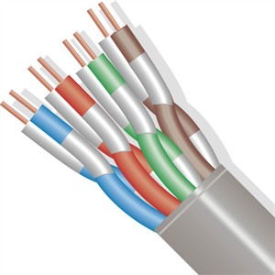](http://www.stanleysupplyservices.com/images/p/502-205.01.GL.jpg)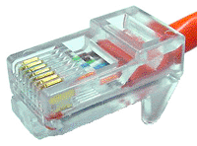

**Multiplexing**

* Combining a number of different data/telephone channels
* On the same cable-copper and fibre



[](http://www.stanleysupplyservices.com/images/p/502-205.01.GL.jpg)

**Category 6 Cabling**

* The latest form of UTP cabling is category 6
* It adds additional quality assurances beyond category 5e
* It is more likely to work as planned after you’ve paid to have it installed
* -Labour costs is by far the largest cost component in cabling
* It comes in 2 forms
* -UTP and screened Twisted Pair (ScTP)
* -ScTP has a layer of metallic foil to improve its interference rejection
* May utilize larger-diameter copper wires
* -Helps for ‘power over Ethernet’ situations

**Shielded Twisted-Pair**

* Shielded twisted pair (STP)
* -Primary used by IBM
* -Should be better than UTP – Shields help prevent interface from outside signal, also help prevent interference to outside signals
* Token ring environments may include a mix of UTP and STP cabling

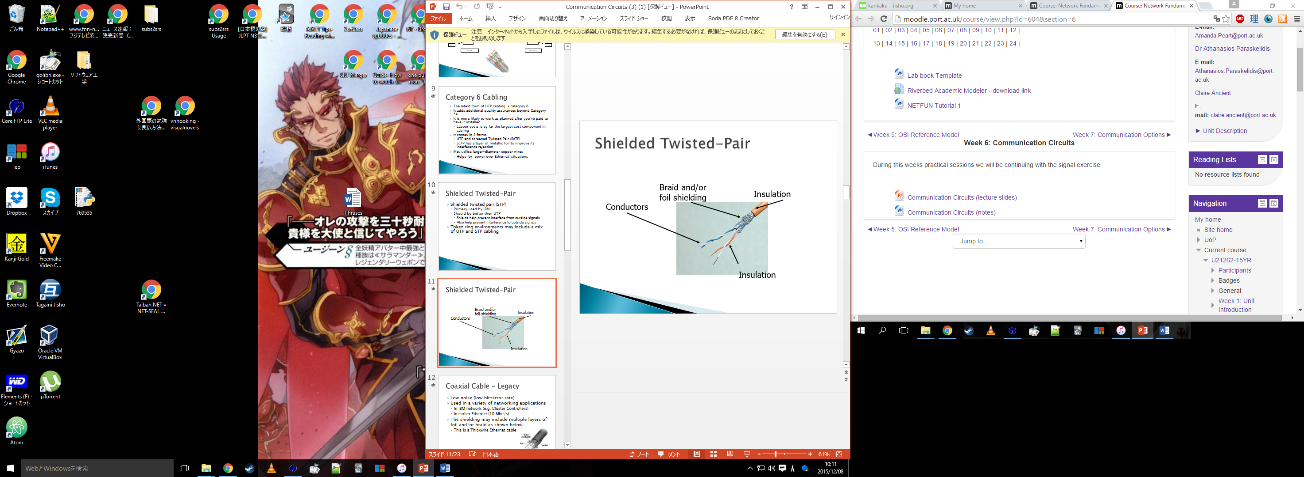

**Coaxial Cable – Legacy**

* Low noise (low bit-error rate)
* Used in a variety of networking applications
* -In IBM network (e.g. cluster controllers)
* -In earlier Ethernet (10 Mbit/s)
* The shielding may include multiple layers of foil and/or braid as shown below
* -This is a Thickwire Ethernet cable

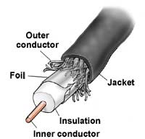

**Fibre-Optic Cables**

* Extremely high data rates
* -More than 100 mbit/s for LAN uses
* -More than 10 times that for telephone company links
* Usage is typically with two unidirectional links, with one fibre in each direction
* Converts electrical signals to light and back to electrical

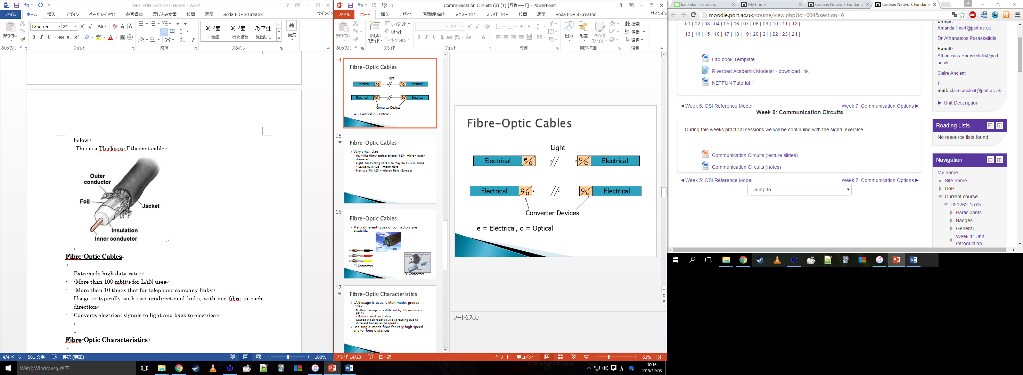

* Very small size
* -Hair-like fibre-optical strand (125- micron outer diameter)
* -Light-conducting core size may be 62.5 microns (Called 62.5/125 – micron fibe
* -May use 50/125 – micron fibre (Europe)

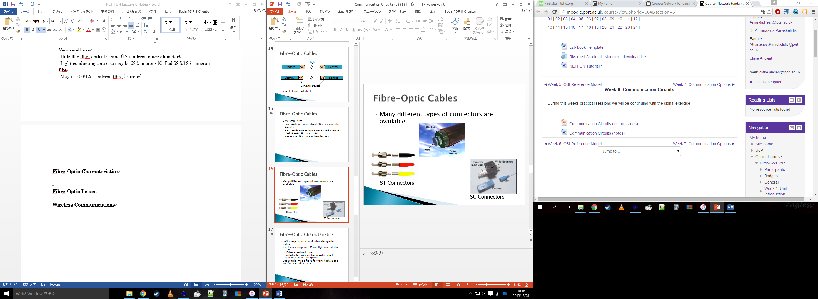

**Fibre-Optic Characteristics**

* LAN usage is usually multimode, graded index
* -Multimode supports different light transmission paths (pulses spread out in time)
* -Graded index resists pulse spreading due to different transmission speeds
* Use single-mode fibre for very high speed and/or long distance
* Best available communications medium
* -Excellent electrical noise immunity
* -Difficult to tap (security)
* -Lightweight
* -Small size

**Fibre-Optic Issues**

* A single fibre may support multiple light beams
* -Dense wave division multiplexing (DWDM)
* -Up to 100 or more simultaneous transmissions
* -Only used with single-mode fibre
* Media converters are available between different media types



**Wireless Communications**

* There are several different forms of wireless communications
* Infrared beams (point-to-point)
* Point-to-point microwave
* -Requires ‘line of sight’ between antennas
* -Antennas are often mounted on towers
* -Requires a license
* Cellular telephones
* -Used for voice and data
* -E-mail access and some Web access
* -‘Always on’ possibilities